
The Gym Center Membership Management system



Submitted By: Submitted To:

Kushal Chapagain Er Bikash Gupta
Pramod Jung Khatri
Rupak Sigdel
Sushant Pokharel

Contents
List of Figure 3
Abstract 4
Acknowledgement 5
Preface 6
Declaration 7
1.Introduction 8
1.1 Overview 8
1.2 Problem Statement 9
1.3 Objective 9
Specific Objectives 9
1.4 Features 10
1.5 Significance 10
Benefits of the System 10
1.6 Limitations and Scope 10
Scope 10
Limitations 11
1.7 Organization of the Document 11
Chapter 1: Introduction 11
Chapter 2: Literature Review 11
Chapter 3: System Analysis and Design 11
Chapter 4: Implementation 11
Chapter 5: Results and Discussion 12
Chapter 6: Conclusion and Future Recommendations 12
References 12
Appendices 12
2.Literature Review 13
1. MINDBODY 13
Features 13
Advantages 13
Limitations 13
2. ABC Fitness 13
Features 13
Advantages 13
Limitations 13
3. Zen Planner 14
Features 14
Advantages 14
Limitations 14
4. Virtuagym 14
Features 14
Advantages 14
Limitations 14
5. Perfect Gym 14
Features 15
Advantages 15
Limitations 15
3.System Analysis and Design 16
ER-Diagram First half 17
ER-Diagram second half 18

List of Figure
Figure 3.1 ER-Diagram of Gym Management System 16
Figure 3.2 ER-Diagram(First Part) 17
Figure 3.3 ER-Diagram(Second Half) 18

Abstract
The Gym Center Membership Management System is a database-driven system designed to efficiently manage the operations of a gym. The main objective of this project is to automate and organize information related to users, trainers, administrators, membership plans, payments, notifications, and contact messages. The system reduces the need for manual record keeping and provides a centralized platform for managing gym activities.
The database is designed using an Entity-Relationship (ER) model that establishes relationships among various entities such as Login, User, Admin, Trainer, Membership Plan, User Membership, Payment, Notification, and Contact Message. Users can register and select membership plans, trainers can supervise members, administrators can manage the overall system, and payments can be tracked efficiently.
The proposed database schema ensures data consistency, minimizes redundancy through normalization, and maintains data integrity using primary and foreign key constraints. It also supports essential gym management functions such as membership tracking, payment management, trainer assignment, and user communication.
This project demonstrates the practical application of database design concepts, including ER modeling, relational schema design, and SQL implementation. The system provides a scalable and efficient solution for managing gym membership information and improving administrative operations within a fitness center.

Acknowledgement
I would like to express my sincere gratitude to everyone who contributed directly or indirectly to the successful completion of this project, "Gym Membership Management System Database Design."
First and foremost, I would like to thank my respected teacher/supervisor for providing valuable guidance, encouragement, and constructive suggestions throughout the development of this project. Their support helped me understand the concepts of database management, ER modeling, and schema design more effectively.
I am also grateful to my college and the Department of Computer Engineering for providing the necessary learning environment and resources required to complete this work.
Special thanks go to my classmates and friends who shared their ideas, offered helpful feedback, and motivated me during different stages of the project.
Finally, I would like to thank my family for their continuous support, patience, and encouragement throughout my academic journey. Their belief in me has been a constant source of motivation.
This project has enhanced my understanding of database design principles, entity-relationship modeling, normalization, and SQL schema development, and I am thankful to everyone who played a role in making it possible

Preface
This project, "Gym Membership Management System Database Design," was developed as a part of the academic requirements of the Computer Engineering program. The project focuses on designing a well-structured database system that can efficiently manage gym-related activities, including member registration, membership plans, trainer management, payment records, notifications, and communication with users.
The primary objective of this project is to apply the theoretical concepts of Database Management Systems (DBMS), Entity-Relationship (ER) modeling, and relational schema design to a real-world application. Through this work, an effort has been made to design a database that is reliable, scalable, and capable of maintaining data integrity while reducing redundancy.
The project provided an opportunity to gain practical knowledge of database design methodologies, normalization techniques, primary and foreign key relationships, and SQL-based schema implementation. It also enhanced the understanding of how database systems support the efficient management of organizational information.
I hope that this project serves as a useful reference for understanding the design and implementation of a Gym Membership Management System and demonstrates the importance of proper database design in modern information systems.

Declaration

We declared that this project report titled “Gym Center Memberahip” submitted in partial fulfillment of the “Bachelor of Computer Engineering” is a record of original work carried out by us under the supervision of Respected “Er.Bikash Gupta” and has not formed the basis for the award of any other degree or diploma, in this or any other Institution or University. In keeping with the ethical practice in reporting scientific information, due acknowledgements have been made wherever the findings of other have been cited.

Kushal Chapagain
Pramod Jung Khatri
Rupak Sigdel
Sushant Pokharel
Date:

1.Introduction
In today's digital era, fitness centers and gyms require efficient systems to manage their daily operations and large volumes of member information. Traditional paper-based record management is often time-consuming, prone to errors, and difficult to maintain. To overcome these challenges, a computerized database system can be implemented to store, manage, and retrieve information accurately and efficiently.
The Gym Membership Management System is a database application designed to automate and simplify the management of gym activities. The system enables administrators to maintain member records, manage trainers, monitor membership plans, process payments, and send notifications to users. It also provides facilities for users to register, select membership plans, and communicate with the gym administration.
This project focuses on the design and implementation of a relational database using Entity-Relationship (ER) modeling and SQL schema design. The database consists of several interconnected entities, including Login, User, Admin, Trainer, Membership Plan, User Membership, Payment, Notification, and Contact Message. These entities work together to ensure efficient data management and support the core functionalities of a gym management system.
The system is designed with proper normalization techniques to minimize data redundancy and maintain data integrity. Primary keys, foreign keys, and relationship constraints are used to establish secure and reliable connections between different tables. As a result, the database provides accurate record keeping, faster data retrieval, improved security, and better overall management of gym operations.
The main goal of this project is to develop a structured and efficient database system that supports the smooth operation of a fitness center while demonstrating the practical application of database management concepts. This project also serves as a learning platform for understanding database design, ER diagrams, normalization, and SQL implementation in real-world scenarios.

1.1 Overview
The Gym Membership Management System is a database-based application designed to manage and automate the daily operations of a gym or fitness center. The system stores and manages information related to members, trainers, administrators, membership plans, payments, notifications, and user inquiries. By replacing traditional manual record-keeping methods with a computerized database system, the gym can maintain accurate records, improve efficiency, and provide better services to its members.
The system uses a relational database structure where different entities are interconnected through relationships. This ensures organized data management, quick retrieval of information, and secure storage of records. The project demonstrates the practical implementation of Database Management System (DBMS) concepts, including ER modeling, normalization, and SQL schema design.

1.2 Problem Statement
Many gyms and fitness centers still rely on manual methods such as paper records, spreadsheets, or separate files to manage member information and daily operations. These methods often lead to data redundancy, loss of records, difficulty in updating information, and inefficient management of memberships and payments.
The major problems faced by traditional gym management systems include:
- Difficulty in maintaining member records accurately.
- Inefficient tracking of membership plans and renewal dates.
- Errors in payment management and record keeping.
- Lack of proper communication between gym administration and members.
- Time-consuming retrieval and updating of information.
- Increased chances of data inconsistency and duplication.
Therefore, there is a need for a centralized database system that can efficiently manage gym operations and ensure accurate data handling.

1.3 Objective
The main objective of the Gym Membership Management System is to design and implement a database that efficiently manages all gym-related information and activities.

Specific Objectives
- To maintain detailed records of gym members.
- To manage trainer information and assignments.
- To store and manage membership plans.
- To track membership registration, renewal, and expiration.
- To maintain payment records and transaction details.
- To provide notification facilities for users.
- To improve data security and integrity.
- To reduce manual work and increase operational efficiency.
- To apply database design concepts in a real-world scenario.

1.4 Features
The Gym Membership Management System provides the following features:
- User registration and login management.
- Administrator account management.
- Trainer information management.
- Membership plan management.
- Member enrollment and membership tracking.
- Payment processing and record maintenance.
- Notification management for members.
- Contact message management.
- Secure storage and retrieval of data.
- Efficient search and reporting capabilities.

1.5 Significance
The significance of the Gym Membership Management System lies in its ability to improve the efficiency and effectiveness of gym operations.

Benefits of the System
- Reduces paperwork and manual record maintenance.
- Improves accuracy in data storage and retrieval.
- Ensures consistency and integrity of information.
- Simplifies membership and payment management.
- Facilitates better communication with members.
- Saves time and administrative effort.
- Provides a scalable database structure for future expansion.
- Enhances understanding of database design concepts and applications.
This project also serves as an educational example of applying DBMS principles in solving real-world management problems.

1.6 Limitations and Scope

Scope
The scope of the project includes:
- Management of users, trainers, and administrators.
- Membership plan creation and management.
- Tracking of member subscriptions and renewals.
- Recording and monitoring payment transactions.
- Sending notifications to members.
- Managing contact messages and inquiries.
- Maintaining secure login and authentication information.

Limitations
Although the system provides essential gym management functionalities, it has some limitations:
- The project focuses only on database design and management.
- Online payment gateway integration is not included.
- Biometric attendance systems are not implemented.
- Advanced analytics and reporting features are not provided.
- Mobile application support is outside the current scope.
- Real-time workout tracking is not included.
Future versions of the system can address these limitations by integrating advanced technologies and additional functionalities.

1.7 Organization of the Document
This report is organized into the following chapters:

Chapter 1: Introduction
Provides an overview of the project, problem statement, objectives, features, significance, scope, limitations, and organization of the report.

Chapter 2: Literature Review
Discusses existing gym management systems, related studies, and technologies used in database management.

Chapter 3: System Analysis and Design
Presents the requirement analysis, ER diagram, database schema, normalization process, and system design.

Chapter 4: Implementation
Describes the implementation of the database using SQL and explains table creation, relationships, and constraints.

Chapter 5: Results and Discussion
Presents the outcomes of the database implementation and discusses system performance and functionality.

Chapter 6: Conclusion and Future Recommendations
Summarizes the project findings and suggests possible improvements and future enhancements.

References
Lists all books, journals, websites, and other resources used during the project.

Appendices
Contains supplementary materials such as SQL scripts, screenshots, ER diagrams, and additional documentation.

2.Literature Review

1. MINDBODY

Features
- Membership management
- Online class booking and scheduling
- Payment processing and billing
- Marketing and customer engagement tools

Advantages
- Comprehensive all-in-one fitness management solution.
- Supports online booking and mobile access.
- Helps improve customer engagement through marketing tools.
- Suitable for large fitness centers and health clubs.

Limitations
- High subscription and maintenance costs.
- Complex setup for small gyms.
- Some advanced features require additional fees.

2. ABC Fitness

Features
- Member registration and management
- Automated billing and payment collection
- Reporting and analytics
- Customer relationship management (CRM)

Advantages
- Highly scalable for growing fitness businesses.
- Provides detailed reports and business insights.
- Automates recurring payments.
- Enhances member retention through CRM features.

Limitations
- Expensive for small and medium-sized gyms.
- Requires training for effective use.
- Some customization options are limited.

3. Zen Planner

Features
- Membership management
- Attendance tracking
- Billing and payment processing
- Class scheduling and booking

Advantages
- User-friendly membership management.
- Suitable for gyms, martial arts, and CrossFit centers.
- Simplifies payment collection.
- Provides useful attendance reports.

Limitations
- Interface may appear outdated.
- Limited advanced customization.
- Initial learning curve for new users.

4. Virtuagym

Features
- Membership management
- Workout planning and tracking
- Nutrition management
- Mobile application support

Advantages
- Combines gym management with fitness tracking.
- Strong mobile application for members.
- Supports personalized workout programs.
- Encourages member engagement through health monitoring.

Limitations
- Premium features require additional payment.
- Can be complex for small gyms.
- Internet connection is required for full functionality.

5. Perfect Gym

Features
- Membership and customer management
- Payment and billing management
- CRM integration
- Reporting and analytics

Advantages
- Suitable for multi-location fitness centers.
- Strong customer relationship management features.
- Provides comprehensive business reports.
- Supports business growth and expansion.

Limitations
- High implementation and subscription costs.
- Requires technical expertise for setup.
- More features than needed for small gyms.

3.System Analysis and Design

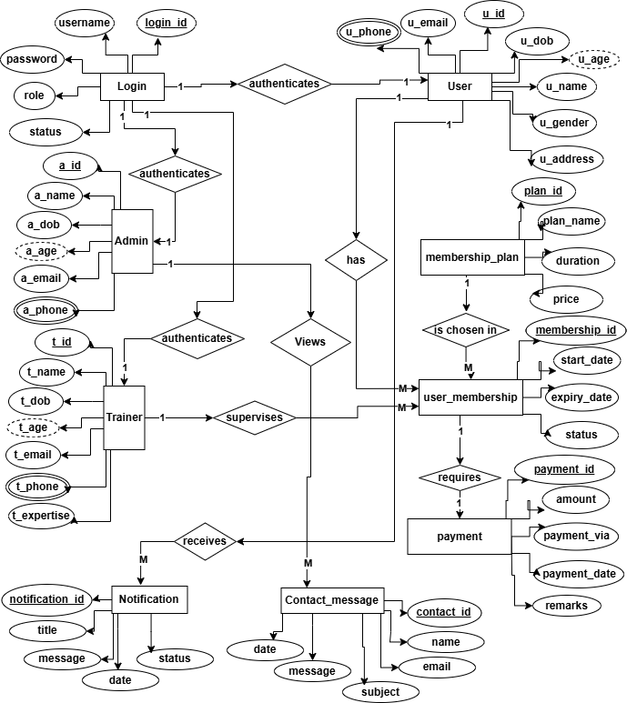
Figure 3.1ER-Diagram of Gym Management System

ER-Diagram First half

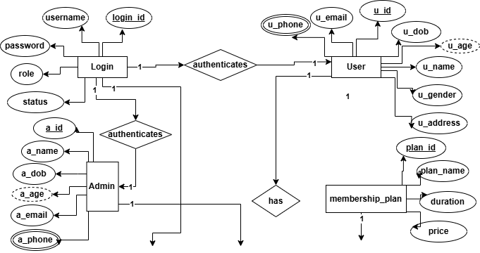
Figure 3.2ER-Diagram (First Part)

ER-Diagram second half

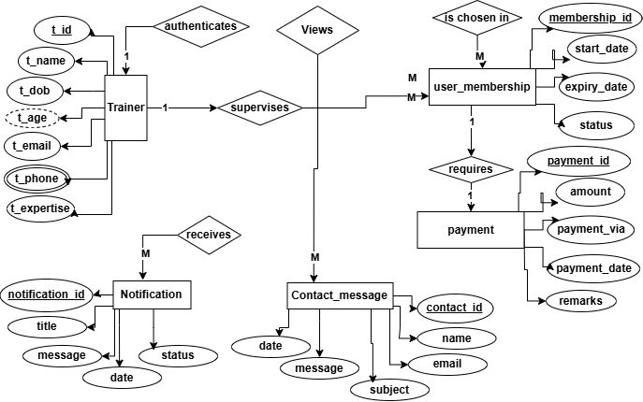
Figure 3.3ER-Diagram (Second Half)

